Academic Writing Style

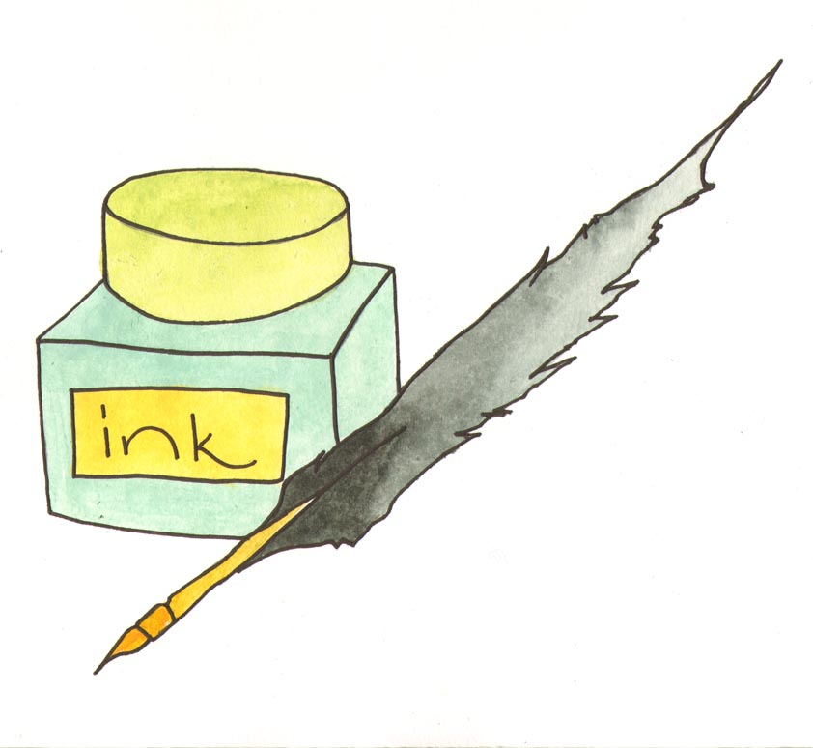

What is an academic writing style?

Academic writing means writing in a more formal style than the language you use in conversation. You are expected to use this style in college but using this style of language in exam answers and essays may gain you extra marks. For academic writing at university:

• Be analytical.
• Don’t just write down everything you know on the subject to which the
question refers.
• Your style should reflect that you have read around the subject and
thought critically about it.
• Show that you understand and can evaluate different angles to an
argument.
• Refer to other critics as well as your primary text. Example: Smith argues
A, and Brown argues B, but it is likely that opinion C is more accurate.

For example when you are quoting from a text think carefully about the verb you use to introduce their ideas:

Rather than Consider Using

Thinks Considers or believes
Asks Questions
Says States or asserts
Sees Observes

Avoid conversational language

Rather than Consider Using

Really Very
A bit Rather
A lot A great deal
Maybe Perhaps

Avoid contracted words

Rather than Consider Using

Can’t Cannot
Doesn’t Does not
It’s It is
Isn’t Is not

Avoid starting sentences with words such as:

Again
Although
Because
But
And

It is not ‘wrong’ to begin a sentence with these words but it is often difficult to control the grammar of the rest of the sentence if you do, and you could stuck in a very long sentence!

Write clearly and concisely

- One argument per paragraph
- One idea per sentence
- You will not be marked down for the use of the first person (‘I’) but if you try and avoid this it will make the focus of the sentence the topic and not you, the writer. For example:

‘I think the writer of this article is trying to make the reader feel sympathetic with his situation, but at the same time there are some amusing parts.’

…could be replaced by …..

‘This article is written in a satirical style which introduces humour to the topic, however despite the use of sarcasm, the reader can still empathise with his situation.’

